

Real Transilvania Official Site

Project Report

DT228/DT282

Computer Science

**Iosif Bogdan Dobos**

School of Computing

Dublin Institute of Technology

**08/12/2016**



Declaration

I hereby declare that the work described in this dissertation is, except where otherwise stated, entirely my own work and has not been submitted as an exercise for a degree at this or any other university.

Signed:

_________________________

Iosif Bogdan Dobos

Date: 08/12/2016

Table of Contents

*1.*Problem Description 1

*2.*Research 1

*3.*Technology Selection and Site Architecture 2

*4.*Low Fidelity Prototype 2

*5.*Development Plan 4

*6.*Testing Plan 5

*7.*Site Evaluation 5

*8.*Deployment 6

*9.*Appendices 6

# *1.*Problem Description

Real Transilvania official website is a basic website created for Real Transilvania team, which are currently playing in Athletic Union League, Premier A. The website that I create start with a background image that represent the logo of Transilvania team. In the top section of the page I create a header adding the name of the club and the logo. Throughout in the right side of the header there is social media icons, where if user click on a respective image, brings it on an external page. For example, if you press on the Facebook icon, its brings you to the Real Transilvania official Facebook page.

Followed true on my HTML I create a white bar and I add a searching box, where users can navigate more easily by searching for a specific file, or a different topic. Then on the right side of the white bar I add a login section where user can login if have already an account and if doesn`t, beside login section there is an create account section and users can create their own personal account. Underneath the white bar is the navigation menu. Users can easily navigate through different pages and view different information that Real Transivania is offer, such us the current news of Real Transilvania family, users can view all the player, photos, videos, etc.

In the HTML Container I split this section in two parts. In the left side I added a section where user can view the most important news of Real Transilvania team, and underneath I create another section with latest news of the team. If click on the news it`s brings in to another page, where there is more information about that news topic. On the right side of the container I create in html two tables where who visit the website can see the next match that Trasilvania is going to have and bellow the other table with Premier A league table, where the team is enrolled at the moment.

Basically, this website was creating for Real Transilvania fans and for all users, which they can have the opportunity to see news about the first team and also about second team. All the news in the website are up to date weekly keeping fans with a fresh memory of what is happening in Real Transilvania family. This site also provides information about the first team but also about team over 35`s. In the menu section users can see all the players who play for this team, and if click on a respective player user can find more details about the respective player. This website offers real time information about fixtures of the first team, when is the next game, the exact time when the game start and on what stadium they will play. This site also provides up to da information about the league table, where this team plays at the moment, and the league table is updated after every game. Users can view images, videos of this teams, and also can view trophies that Real Transilvania won in different competitions that this team was involved. I have included in my website sponsors the teams and the different types of business they do. It`s like advertisement for them, and a brief description of their services.

# *2.*Research

Before creating this website, I did a lot of research in finding a site layout and content that make this website easy to navigate and having a good aspect. All the website pages that I researched was relating to the football topic, more specific about a football team. One of the site that I research was of Fc Liverpool website, I evaluate the site layout and site content, then I started to have an idea. The other website page that I researched was of Manchester United, Mancheter City, and Real Madrid, which is one of my favourite team. Evaluating the site layout and site content I started to have an idea how the Real Transilvania website it`s going to look.

# *3.*Technology Selection and Site Architecture

This website uses version 5 of HTML/CSS. After having a good researching on different websites’, and having an idea how the website will look, I start drawing a wireframe for this website detailing all the elements that will be in the website. The site layout that I chose for this website represents the colour of Real Transilvania jersey which are blue and yellow, and the background of this site represent the logo of this team. Also this website is compatible in all browser across.

# *4.*Low Fidelity Prototype

For the Lo-Fi prototype I use a wireframe to describe the site content and site layout

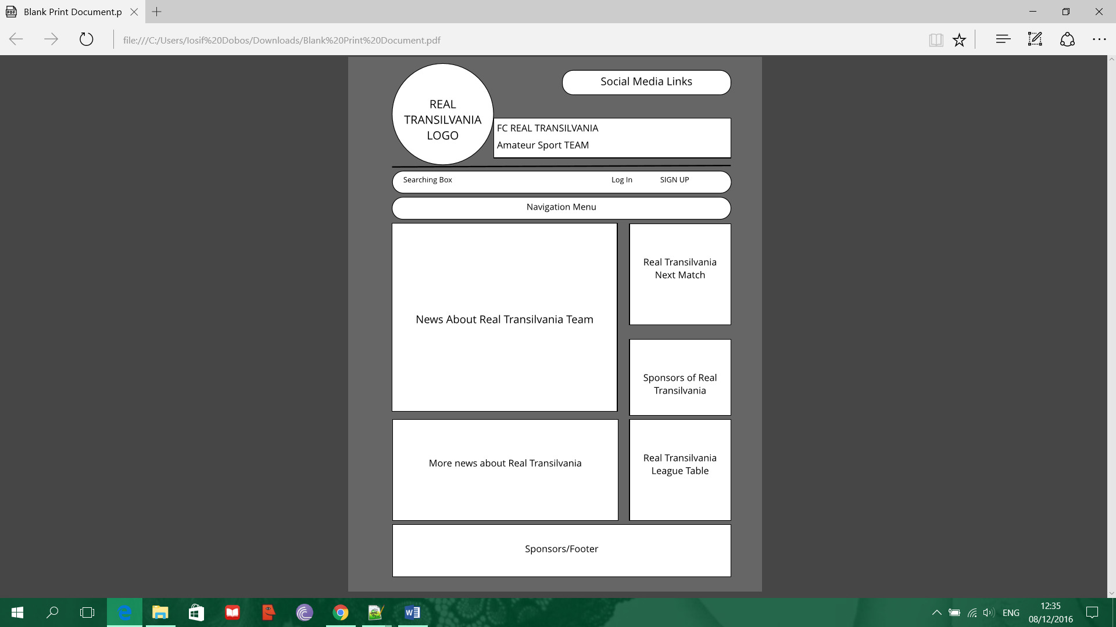

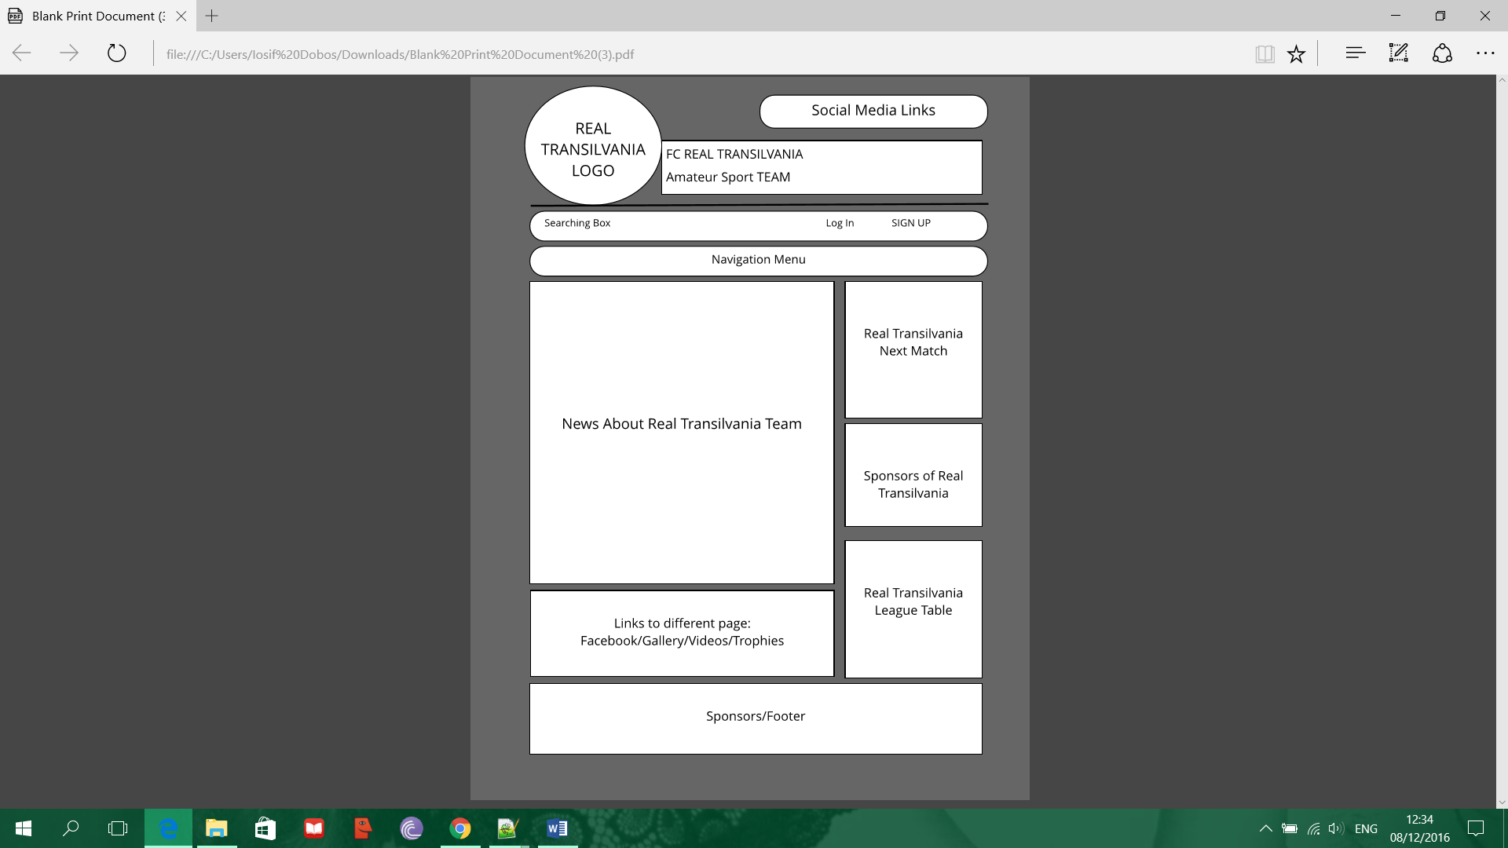

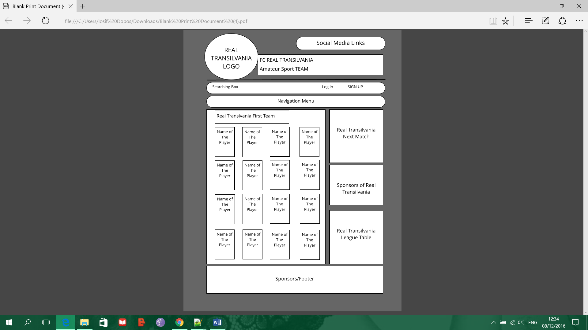

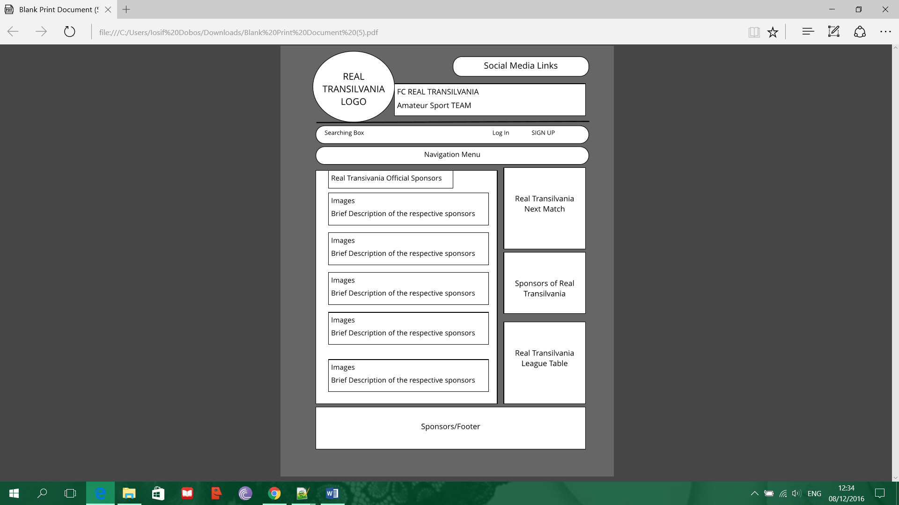

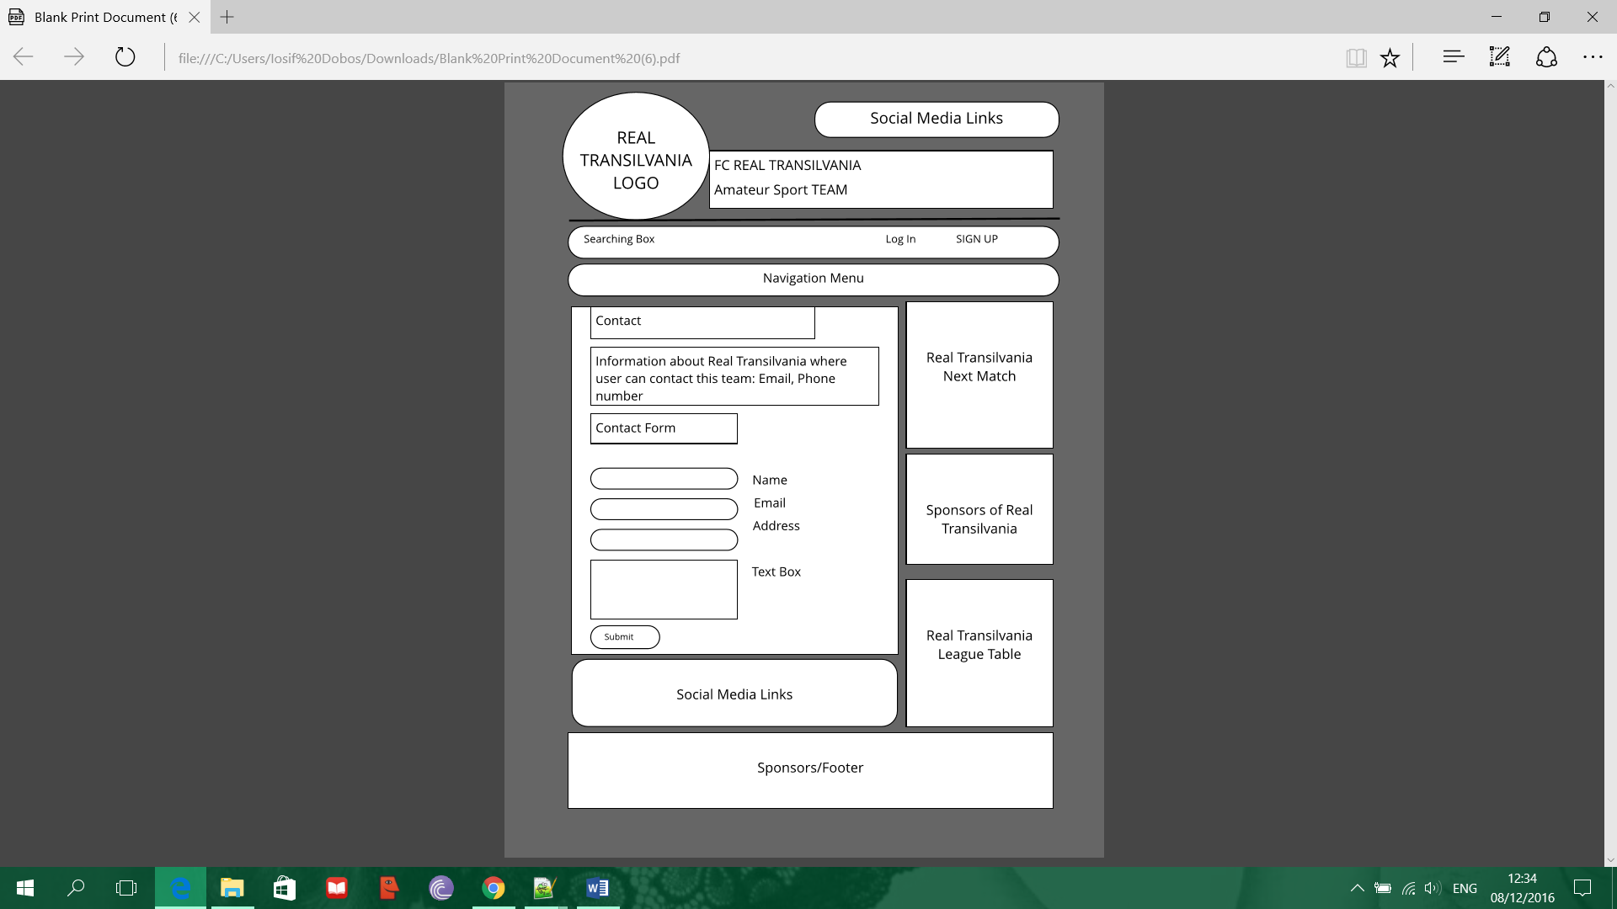

# *5.*Development Plan

Before start the website, I did some research on different pages related to the topic that I chose, and I had created an idea about designed my website. Then I started drawing a wireframe of my website. I decided to create a web page when users accessing this page, to find all the information about this team, and as well users can easy navigate on this website. I decided that my website to have a background that represent this team, and the header to be with the logo and the name of this team. I wanted this website to have a search bar where users can quickly search in the site, also in the search bar users can create an account, and if already have one they can log in. In the main container I have decided to divide this section in two parts. On the left I add news about the team, to keep fans up to date of what is happening in this team. On the right side of the container section I created a table where I decided to add information about the matches that this team will be playing, keeping fans up to date, and underneath I created a league table where this team plays at the moment, so the fans can see on what position is this team. In the footer section, I added all the sponsors who support this team, and bellow I add the terms and conditions about this team.

# 

# *6.*Testing Plan

For the testing plan I used the site <https://www.w3.org/> where first thing that I did, I create the home page, body, footer, container and footer and then I upload the html file and the CSS to this site. I modify the html page but I still have error and warnings, and after I copied the layout in all other pages keeping all other pages with the same layout. After I check different browsers to test if my page is compatible. And yes my page is compatible in almost all the browsers across.

# *7.*Site Evaluation

You must describe how you evaluated your website using appropriate heuristics.

For evaluate this site, I have proposed to write down few question to myself relating to my website and see if my website meet some requirements answering to this questions honestly.

1. Who is the author of this site?

The author of this site is computer science student trying to me a master in web development.

1. What is the purpose of this site?

This is a personal website creating for my Continuous Assessment on Web Development.

1. What does the website provide?

This website aims to provide information for players and fans of Real Transilvania. It gives updates of fixtures and result as well as information about team performance, also it gives information about the players.

1. Does the website provide any contact information?

Yes, this website provides a contact page where users can find all the contact details and also is a form where users can complete it, if they wish to contact us.

1. Is the site well maintained and updated?

This site is well maintained and all the new information is updated weekly, also if any important information appears, keeping the players and fans of this team informed with up to date information.

1. In your opinion, how does this website appear overall?

In my opinion this site is very well designed and organized. Also allow users to navigate easily and all the information are easy to read.

# *8.*Deployment

TCP is a [connection-oriented](http://searchnetworking.techtarget.com/definition/connection-oriented) protocol, which means a connection is established and maintained until the [application programs](http://searchsoftwarequality.techtarget.com/definition/application-program) at each end have finished exchanging [messages](http://whatis.techtarget.com/definition/messaging). It determines how to break application data into packets that [networks](http://searchnetworking.techtarget.com/definition/network) can deliver, sends packets to and accepts packets from the network layer, manages [flow control](http://whatis.techtarget.com/definition/flow-control), and because it is meant to provide error-free data transmission handles retransmission of dropped or garbled packets as well as acknowledgement of all packets that arrive.  In the [Open Systems Interconnection](http://searchnetworking.techtarget.com/definition/OSI) (OSI) communication model, TCP covers parts of Layer 4, the [Transport Layer](http://searchnetworking.techtarget.com/definition/Transport-layer), and parts of Layer 5, the [Session Layer](http://searchnetworking.techtarget.com/definition/Session-layer).

The way that this website was made it available online was. I went through the website <https://www.000webhost.com/> , which is a website that can get free hosting domain servers as part of the CA requirements, and making the page available online on the internet. To make your page available requires few steps need to be done. First step is to create an account; some details need to be introduced for your profile. Then there is a section on the website build your website. Click on that icon, then click on the upload own website. There is all the section needed then you have to upload all the html file, the CSS, all the images, and the java script file, to make the page available online.

# *9.*Appendices

Weekly Project Report – Week 9

My Continuous Assessment for Web Development is about a football soccer team that I playing for. The layout and theme is based on the Romanian national team colours, because all the players are from Romanian living in Ireland. The team is playing every Sunday and sometimes on Friday. I`ve created a templates and a wireframe that reflect Romanian team. In the website I`ve created a page which include all the players from the first team and also the second team over 35`s. In the header section I add the Real Transilvania name and logo. Then I create a search bar, sign in and create an account. I create the navigation menu which lead the user into different pages with different topics. In the container section I create 2 different side. In the left side I add news with Transilvania team which are updated every time and in the right side I create a table with the real transilvania matches and bellow another table with Premier A league table where Real Transilvania is playing at the moment. The website is updated weekly, daily, whenever necessary.

Weekly Project Report – Week 10

For my CA this week I`ve created some extra html pages that I added to my website the pages are about news of Real Transilvania team, keep the fans up to date with what happens in Real Transilvania family. I also create a search bar that allows user to navigate more easily on site, searching for things and so on. On the search bar there is a section where you can create an account and to sign in. This section allows fans to be a member and they can leave an opinion, leave a comment and so on.

Weekly Project Report – Week 11

This week working on my project I`ve created another html page which I`ve added a table with all the Real Transilvania players. I also added a few extra link-pages where you can view all the goalkeepers, midfielders, strikers and the technical staff. On the bottom of the page there is another link-page that brings the user to the other team the Over 35`s. I had to change a bit of the layout in this page due to the fact that I had problems in creating a dropdown menu. I`ve spent lot of time trying to figure out and solve the problem but I couldn’t seem to resolve the issue, so I decided to create a simple navigation menu without the dropdown menu. But where necessary I added extra html link-page which leads to another page with a different topic. On my home page I added another table with social media, that when the user clicks on a photo, which brings the user to a social media site like facebook twitter etc. depending on the photo selected. Also on the footer I created an area where I introduced all the Real Transilvania sponsors and underneath is another section with terms and condition.

Weekly Project Report – Week 12

This week working on my project for Web Development, after a while I figured out how to make my dropdown to work. In my website page in the Team section I create a table with all Real Transilvania player and when user click on a respective player it brings you on another page, where user will find all the information about the respective player like, full name, date of birth, nationality, and more extra information about. Adding information for all the player requires long time, due to the fact that I had to contact different players and gather information about them. Likewise, I started to work on the project report and add information regarding my website project trying to approach to the finish making my work much easier.